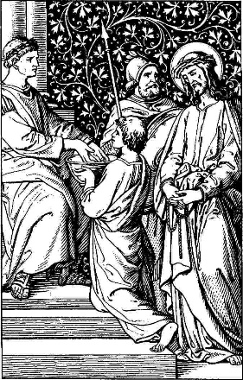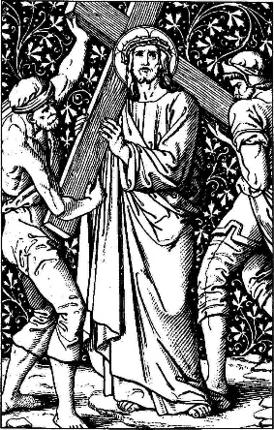
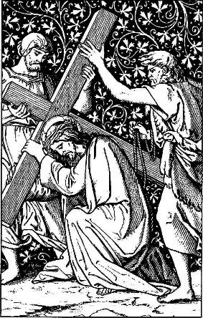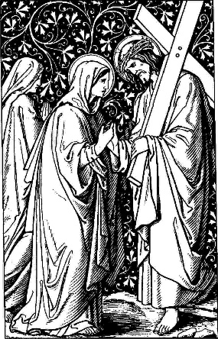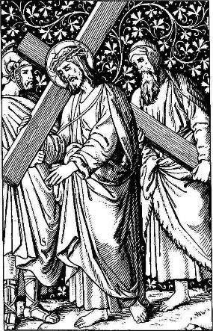
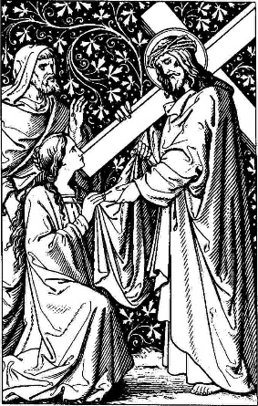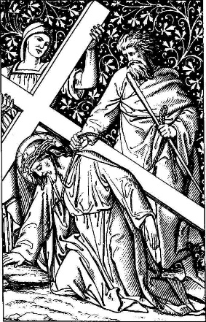

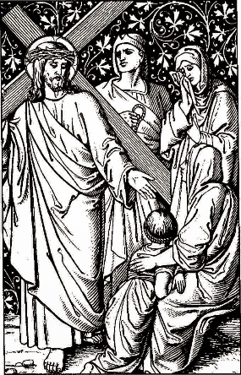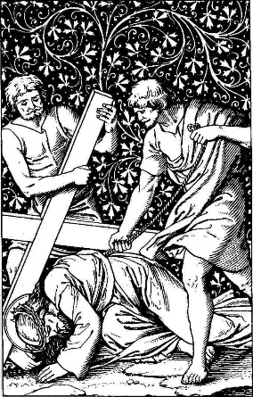
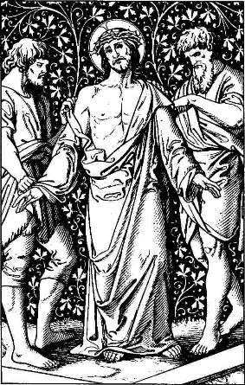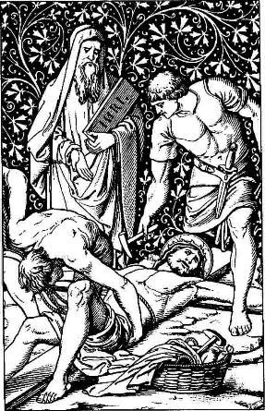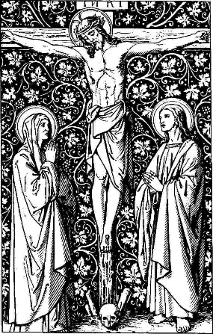
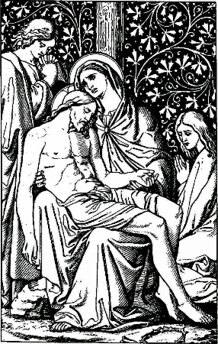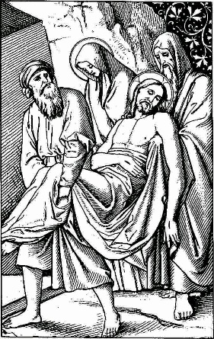
Stations of the Cross

(Adapted from the Anglican Services Book, 1991)

The practice of pilgrims to the Holy Land following the Way of Sorrows from the house of Pilate to the Holy Sepulchre was the origin of this devotion, which became widespread in the later Middle Ages, although it was not completely formalized until the eighteenth century. This is a popular and appropriate devotion during Lent and Holy Week. Eight of the stations are based directly upon events recorded in the Gospels. The remaining six (stations III, IV, VI, VII, IX, and XIII) are based upon inferences from the Gospels or upon pious legend, and may be omitted if desired.

Preparation

In the Name of the Father, and of the Son, and of the Holy Ghost. Amen.

Lord, have mercy upon us.
Christ, have mercy upon us.
Lord, have mercy upon us.

Our Father, who art in heaven, hallowed be thy Name. Thy kingdom come, thy will be done, on earth as it is in heaven. Give us this day our daily bread. And forgive us our trespasses, as we forgive those who trespass against us. And lead us not into temptation, but deliver us from evil. Amen.

V. God forbid that I should glory:
R. Save in the Cross of our Lord Jesus Christ.

Let us pray.

Almighty God, we beseech thee graciously to behold this thy family, for which our Lord Jesus Christ was contented to be betrayed, and given up into the bands of wicked men, and to suffer death upon the cross; who now liveth and reigneth with thee and the Holy Ghost ever, one God, world without end. Amen.
(Collect for Good Friday, BCP p156)

Stanzas of the hymn, Stabat Mater, may be sung before each station (Hymnal 1940, #76).

At the Cross her station keeping
Stood the mournful mother weeping,
Where he hung, the dying Lord.

For her soul of joy bereaved,
Bowed with anguish, deeply grieved,
Felt the sharp and piercing sword.

I. Jesus is Condemned to Death

V. We adore thee, O Christ, and we bless thee,
R. Because by thy holy Cross thou hast redeemed the world.

And straightaway in the morning the chief priests held a consultation with the elders and scribes and the whole council, and bound Jesus, and carried him away, and delivered him to Pilate. (Mark 15:1)
And they all condemned him to be guilty of death. (Mark 14:64b)
When Pilate therefore heard that saying, he brought Jesus forth, and sat down in the judgment seat in a place that is called the Pavement, but in the Hebrew, Gabbatha. (John 19:13)
Then delivered he him unto them to be crucified. And they took Jesus and led him away. (John 19:16)

V. God spared not his own Son:
R. But delivered him up for us all.

Let us pray.

Grant, we beseech thee, Almighty God, that we, who for our evil deeds do worthily deserve to be punished, by the comfort of thy grace may mercifully be relieved; through our Lord and Savior Jesus Christ. Amen.
(Collect for the 4th Sunday in Lent, BCP p130)

Who, on Christ’s dear mother gazing,
Pierced by anguish so amazing,
Born of woman, would not weep?

II. Jesus Takes up His Cross

V. We adore thee, O Christ, and we bless thee,
R. Because by thy holy Cross thou hast redeemed the world.

And he bearing his cross went forth into a place called the place of a skull, which is called in the Hebrew Golgotha. (John 19:17)
Though he were a Son, yet learned he obedience by the things which he suffered. (Hebrews 5:8)
He was led as a sheep to the slaughter; and like a lamb dumb before his shearer, so opened he not his mouth. (Acts 8:32, Isaiah 53:7)
Worthy is the Lamb that was slain to receive power, and riches, and wisdom, and strength, and honor, and glory, and blessing. (Revelation 5:12)

V. The Lord hath laid on him the iniquity of us all:
R. For the transgression of his people was he stricken.

Let us pray.

Almighty God, whose most dear Son went not up to joy but first he suffered pain, and entered not into glory before he was crucified; Mercifully grant that we, walking in the way of the cross, may find it none other than the way of life and peace; through the same thy Son Jesus Christ our Lord. Amen.
(Collect for the Monday Before Easter, BCP p138)

Who, on Christ’s dear mother thinking
Such a cup of sorrow drinking,
Would not share her sorrows deep?
III. Jesus Falls the First Time

V. We adore thee, O Christ, and we bless thee,
R. Because by thy holy Cross thou hast redeemed the world.

Christ Jesus, being in the form of God, thought it not robbery to be equal with God: but made himself of no reputation, and took upon him the form of a servant, and was made in the likeness of men: and being found in fashion as a man, he humbled himself, and became obedient unto death, even the death of the cross. Wherefore God also hath highly exalted him, and given him a name which is above every name. (Philippians 2:6-9)
O come, let us worship and fall down, and kneel before the Lord our Maker, for he is the Lord our God. (Psalm 95:6-7a)

V. Surely he hath borne our griefs:
R. And carried our sorrows.

Let us pray.

O God, who knowest us to be set in the midst of so many and great dangers, that by reason of the frailty of our nature we cannot always stand upright; grant to us such strength and protection, as may support us in all dangers, and carry us through all temptations; through Jesus Christ our Lord. Amen.
(Collect for the 4th Sunday After Epiphany, BCP p114)

For his people’s sins chastised,
She beheld her Son despised,
Scourged, and crowned with thorns entwined.

IV. Jesus Meets His Mother

V. We adore thee, O Christ, and we bless thee,
R. Because by thy holy Cross thou hast redeemed the world.

What shall I testify unto thee? What shall I liken to thee, O daughter of Jerusalem? What shall I compare to thee, that I may comfort thee, O virgin daughter of Zion? For thy ruin is deep as the sea: who can heal thee? (Lamentations 2:13)
Blessed are they that mourn: for they shall be comforted. (Matthew 5:4)
The Lord shall be thine everlasting light, and the days of thy mourning shall be ended. (Isaiah 20:19b)

V. A sword shall pierce through thine own soul also:
R. That the thoughts of many hearts may be revealed.

Let us pray.

We beseech thee, O Lord, pour thy grace into our hearts; that, as we have known the incarnation of thy Son Jesus Christ by the message of an angel, so by his cross and passion we may be brought unto the glory of his resurrection; through the same Jesus Christ our Lord. Amen.
(Collect for the Annunciation of the Blessed Virgin Mary, BCP p235)

Saw him then from judgment taken,
And in death by all forsaken,
Till his spirit he resigned.

V. The Cross is Laid upon Simon of Cyrene

V. We adore thee, O Christ, and we bless thee,
R. Because by thy holy Cross thou hast redeemed the world.

And as they came out, they found a man of Cyrene, Simon by name, coming out of the country (Matthew 27:32),
and on him they laid the cross, that he might bear it after Jesus. (Luke 23:26)
If any man will come after me, let him deny himself, and take up his cross and follow me. (Luke 9:23)
Take my yoke upon you and learn of me; for my yoke is easy, and my burden light. (Matthew 11:29-30)

V. Whosoever doth not bear his cross and come after me:
R. Cannot be my disciple.

Let us pray.

O God, whose blessed Son did overcome death for our salvation: Mercifully grant that we who have his glorious passion in remembrance may take up our cross daily and follow him; through the same thy Son Jesus Christ our Lord. Amen.
(Collect for Holy Cross Day, 1979BCP p192)

Jesus, may her deep devotion
Stir in me the same emotion,
Fount of love, Redeemer kind.

VI. A Woman Wipes the Face of Jesus

V. We adore thee, O Christ, and we bless thee,
R. Because by thy holy Cross thou hast redeemed the world.

He hath no form or comeliness; and when we see him, there is no beauty that we should desire him. He was despised and rejected of men; a man of sorrows, and acquainted with grief: and we hid as it were our faces from him: he was despised, and we esteemed him not. (Isaiah 53:3)
His visage was so marred more than any man, and his form more than the sons of men. (Isaiah 52:14)
He was wounded for our transgressions, he was bruised for our iniquities; the chastisement of our peace was upon him; and with his stripes we are healed. (Isaiah 53:5)

V. Turn us again, O Lord God of hosts:
R. Show us the light of thy countenance, and we shall be whole.

Let us pray.

O God, who before the passion of thine only begotten Son didst reveal his glory upon the holy mount: Grant unto us thy servants, that in faith beholding the light of his countenance, we may be strengthened to bear the cross, and be changed into his likeness from glory to glory: through the same Jesus Christ our Lord. Amen.
(Collect for the Last Sunday After the Epiphany, 1979BCP p165)

That my heart fresh ardor gaining,
And a purer love attaining,
May with thee acceptance find.
VII. Jesus Falls the Second Time

V. We adore thee, O Christ, and we bless thee,
R. Because by thy holy Cross thou hast redeemed the world.

Surely he hath borne our griefs and carried our sorrows. All we like sheep have gone astray; we have turned everyone to his own way; and the Lord hath laid on him the iniquity of us all. He was oppressed, and he was afflicted, yet he opened not his mouth: for the transgression of his people was he stricken. (Isaiah 53:4,6,7)

V. But as for me, I am a worm and no man:
R. A very scorn of men, and the outcast of my people.

Let us pray.

Almighty and everlasting God, who, of thy tender love towards mankind, hast sent thy Son, our Savior Jesus Christ, to take upon him our flesh and to suffer death upon the cross, that all mankind should follow the example of his great humility; Mercifully grant that we may both follow the example of his patience, and also be made partakers of his resurrection; through the same Jesus Christ our Lord. Amen.
(Collect for Palm Sunday, BCP p134)
True repentance, Jesus, win me:
Savior print thy wounds within me.
Brand them on my stubborn heart.

As thou bought’st, through tribulation,
In thy passion, my salvation,
Let me bear therein my part.
VIII. Jesus Meets the Women of Jerusalem

V. We adore thee, O Christ, and we bless thee,
R. Because by thy holy Cross thou hast redeemed the world.

And there followed him a great company of people, and of women which also bewailed and lamented him. But Jesus turning unto them said, “Daughters of Jerusalem, weep not for me, but weep for yourselves, and for your children.” (Luke 23:27-28)

V. They that sow in tears:
R. Shall reap in joy.

Let us pray.

Almighty and everlasting God, who hatest nothing that thou hast made, and dost forgive the sins of all those who are penitent: Create and make in us new and contrite hearts, that we, worthily lamenting our sins and acknowledging our wretchedness, may obtain of thee, the God of all mercy, perfect remission and forgiveness; through Jesus Christ our Lord. Amen.
(Collect for Ash Wednesday, BCP p124)

Let me mourn, O Lord, beside thee
For the sins which crucified thee,
While my life remains in me.

IX. Jesus Falls the Third Time

V. We adore thee, O Christ, and we bless thee,
R. Because by thy holy Cross thou hast redeemed the world.

O my people, what have I done unto thee, or wherein have I wearied thee? Testify against me. Because I brought thee forth from the land of Egypt, thou hast prepared a Cross for thy Savior. Because I led thee through the desert forty years, and fed thee with manna, and brought thee into a land exceeding good, thou hast prepared a Cross for thy Savior. What more could I have done unto thee that I have not done? (“The Reproaches,” a medieval Good Friday liturgy based on Micah 6)

V. He was led as a sheep to the slaughter:
R. And like a lamb dumb before his shearer, so opened he not his mouth.

Let us pray.

Keep, we beseech thee, O Lord, thy Church with thy perpetual mercy; and, because the frailty of man without thee cannot but fall, keep us ever by thy help from all things hurtful and lead us to all things profitable to our salvation; through Christ our Lord. Amen.
(Collect for the 15th Sunday After Trinity, BCP p210)

Take beneath the cross my station.
And in all thy desolation
so unite myself with thee.

X. Jesus is Stripped of His Garments

V. We adore thee, O Christ, and we bless thee,
R. Because by thy holy Cross thou hast redeemed the world.

And when they were come unto a place called Golgotha, that is to say, place of a skull, they gave him vinegar to drink mingled with gall: and when he had tasted thereof, he would not drink. And they parted his garments, casting lots: that it might be fulfilled which was spoken by the prophet, “They parted my garments among them, and upon my vesture did they cast lots.” (Matthew 27:33-35)

V. They gave me gall to eat:
R. And when I was thirsty they gave me vinegar to drink.

Let us pray.

O Lord God, whose blessed Son, our Savior, gave his back to the smiters and hid not his face from shame: Grant us grace to take joyfully the sufferings of the present time, in full assurance of the glory that shall be revealed; through the same thy Son Jesus Christ our Lord. Amen.
(Collect for the Tuesday Before Easter, BCP p144)

Jesus, great beyond all other,
Turn not from me, heav’nly brother,
Let me too bewail thy pain.

XI. Jesus is Nailed to the Cross

V. We adore thee, O Christ, and we bless thee,
R. Because by thy holy Cross thou hast redeemed the world.

And when they were come to the place which is called Calvary, there they crucified him. (Luke 23:33)
And with him they crucified two thieves; the one on his right hand, and the other on his left. And the scripture was fulfilled, which saith, “And he was numbered with the transgressors.” (Mark 15:27-28)
O my people, what have I done unto thee? I did raise thee on high with great power: and thou hast hanged me upon the gibbet of the Cross. (“The Reproaches,” a medieval Good Friday liturgy based on Micah 6)

V. I, if I be lifted up:
R. Will draw all men unto me.

Let us pray.

O God, who by the passion of thy blessed Son hast made the instrument of shameful death to be unto us the means of life and peace: Grant us so to glory in the Cross of Christ, that we may gladly suffer shame and loss; for the sake of the same thy Son our Lord. Amen.
(Collect for Tuesday in Holy Week, 1979BCP p168)

Let my soul, thy death declaring,
Thy unsparing passion sharing,
Count thy bruises one by one.

XII. Jesus Dies on the Cross

V. We adore thee, O Christ, and we bless thee,
R. Because by thy holy Cross thou hast redeemed the world.

When Jesus therefore saw his mother, and the disciple standing by, whom he loved, he saith unto his mother, “Woman, behold thy son!” Then saith he to the disciple, “Behold thy mother!” When Jesus therefore had received the vinegar, he said, “It is finished.” (John 19:26,27,30)
And when Jesus had cried with a loud voice, he said, “Father, into thy hands I commend my spirit.” (Luke 23:50)
And he bowed his head, and gave up the ghost. (John 19:30)

All kneel. Then may be said the Our Father silently, after which all rise.

V. Christ for our sake became obedient unto death:
R. Even the death of the Cross.

Let us pray.

O God, who for our redemption didst give thine only-begotten Son to the death of the Cross, and by his glorious resurrection hast delivered us from the power of our enemy; Grant us so to die daily from sin, that we may evermore live with him in the joy of his resurrection; through the same thy Son Christ our Lord. Amen.
(Collect for Easter Day, BCP p165)
Let thy stripes and scourging smite me;
At thy holy Cross requite me,
Let thy blood refresh me there.

XIII. The Body of Jesus is Placed in the Arms of His Mother

V. We adore thee, O Christ, and we bless thee,
R. Because by thy holy Cross thou hast redeemed the world.

All ye that pass by, behold, and see if there be any sorrow like unto my sorrow. (Lamentations 1:12)
Mine eyes do fail with tears, my bowels are troubled; my liver is poured upon the earth, for the destruction of the daughter of my people. (Lamentations 2:11)
Call me not Naomi (which is Pleasant), call me Mara (which is Bitter); for the Almighty hath dealt very bitterly with me. (Ruth 1:20, clarification added)

V. Her tears are on her cheeks:
R. She hath none to comfort her.

Let us pray.

Grant, we beseech thee, merciful Lord, to thy faithful people pardon and peace, that they may be cleansed from all their sins, and serve thee with a quiet mind; through Jesus Christ our Lord. Amen.
(Collect for the 21st Sunday After Trinity, BCP p218)

O how sad and sore distressed
Now was she, that mother blessed
Of the sole-begotten One.

XIV. Jesus is Laid in the Tomb

V. We adore thee, O Christ, and we bless thee,
R. Because by thy holy Cross thou hast redeemed the world.

When the even was come, there came a rich man of Arimathaea, named Joseph, who also himself was Jesus’ disciple; he went to Pilate, and begged the body of Jesus. Then Pilate commanded the body to be delivered. And when Joseph had taken the body, be wrapped it in a clean linen cloth, and laid it in his own new tomb, which he had hewn out in the rock: and he rolled a great stone to the door of the sepulchre, and departed. (Matthew 27:57-60)

V. Thou shalt not leave my soul in hell:
R. Neither shalt thou suffer thy Holy One to see corruption.

Let us pray.

Grant, O Lord, that as we are baptized into the death of thy blessed Son, our Savior Jesus Christ, so by continual mortifying our corrupt affection we may be buried with him; and that through the grave, and gate of death, we may pass to our joyful resurrection; for his merits, who died, and was buried, and rose again for us, the same thy Son Jesus Christ our Lord. Amen.
(Collect for Easter Even, BCP p161)

Deep the woe of her affliction,
When she saw the crucifixion
Of her ever glorious Son.

Here may be said the Apostles’ Creed (BCP p15).

I believe in God the Father Almighty, Maker of heaven and earth: And in Jesus Christ his only Son our Lord: Who was conceived by the Holy Ghost, Born of the Virgin Mary: Suffered under Pontius Pilate, Was crucified, dead, and buried: He descended into hell; The third day he rose again from the dead: He ascended into heaven, And sitteth on the right hand of God the Father Almighty: From thence he shall come to Judge the quick and the dead. I believe in the Holy Ghost: The holy Catholic Church; The Communion of Saints: The Forgiveness of sins: The Resurrection of the body: And the Life everlasting.
Amen.

V. O Savior of the world, who by thy Cross and precious Blood hast redeemed us
R. Save us and help us, we humbly beseech thee, O Lord.

Let us pray.

Almighty Father, who hast given thine only Son to die for our sins, and to rise again for our justification; Grant us so to put away the leaven of malice and wickedness, that we may always serve thee in pureness of living and truth; through the merits of the same thy Son Jesus Christ our Lord. Amen.
(Collect for the 1st Sunday After Easter, BCP p170)

The grace of our Lord Jesus Christ, the love of God, and the fellowship of the Holy Ghost be with us all evermore. Amen. (2 Corinthians 14:14)

